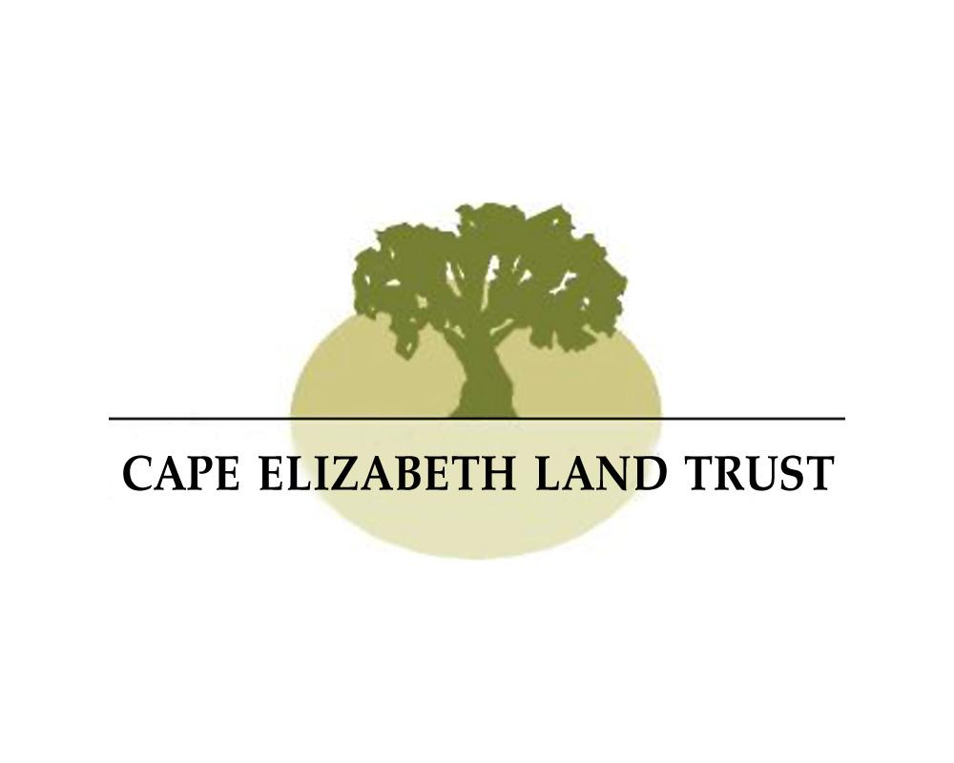

Dear Cape Elizabeth Educators:

The Cape Elizabeth Land Trust solicits proposals for mini-grants for teachers in the Cape Elizabeth school district to provide funding for environmentally-based projects to benefit Cape students. As you may know, the Cape Elizabeth Land Trust (CELT) is a non-profit, membership organization. CELT’s mission is to permanently conserve and provide stewardship for lands cherished by our community - from shore lands to marshes, from farmlands to woodlands - for the education, use and enjoyment of this and future generations. CELT now protects, through ownership or by easement, over 800 acres of historic, scenic and ecologically significant farmland, woods, wetlands and shore land in Cape Elizabeth.

The goal of CELT’s providing mini-grants to Cape teachers is to enable teachers to develop their own curricula based upon the ecological features of protected properties in Cape Elizabeth and/or to assist Cape students to learn more about protected areas. The mini-grants will be available for materials, tools, training and resource materials, workshop or conference fees, speakers, or field trip expenses that enhance classroom curriculum in the areas of natural science and conservation.

Applications for mini-grants are accepted from September to June for the current school year on a rolling basis and grants are awarded first come, first serve. We will award a maximum of $500 for three grants for the 2024/2025 school year. If you are a Cape teacher with an idea to get your students more involved in the environment around them, we encourage you to apply!

Please contact Ali by email (ali@capelandtrust.org) or call our office at (207) 767-6054 if you have any questions

Sincerely,

Ali Gustavson, Education Program Coordinator

CC: Education Committee

Cape Elizabeth Land Trust



MINI-GRANT PROPOSAL

**Name:** __________________________ **Grade:** _______________________

**School:** (Please check) ______ Pond Cove _____Middle School _____High School

**Subject of Study:** ______________________________________________________

**Proposal:** (Please describe proposed project/activity in space provided; if additional space is needed, please limit to 2 pages or fewer.)

**Persons involved:**

**Timeline for implementation of project/activity:**

**Location of project/activity proposed:**

(NOTE: If taking place here, you must include us in your scheduling conversations with any outside education provider, ie Chewonki)

**Explain CELT Mini-Grant’s benefit to students and relation to current classroom curriculum:**

**Total cost of proposed project/activity:**

**Please inform whether and where funding for this proposed project/activity has been previously applied for?**

**Additional comments, explanation, information:**

**Signature:** ___________________________ **Date:** ___________________________

Cape Elizabeth Land Trust 330 Ocean House Road Cape Elizabeth, Maine 04107

207-767-6054 [info@capelandtrust.org](mailto:info@capelandtrust.org) [www.capelandtrust.org](http://www.capelandtrust.org)